The Open University of Sri Lanka
B.Sc./B.Ed Degree Programme-Level 05-2010/11
BTU 3105/BTE 5105 – Soils and Plant Growth
Assessment Test II(No Book Test)

Duration – One (01) hour Reg.No. ……………………

Date: 8th April 2011 Time: 4.00p.m. – 5.00p.m.

Answer all questions on this paper itself.

There are three (03) questions and five (05) pages in this question paper.

a. List the factors that affect on the rate of organic matter decomposition.
………………………………………………………………………………………………………………………………………………………………………………………………………………………………………………………………………………………………………………………………………………………………………………………………………………………………………………………………………………………………………………………………………………………………………………………………………………………………………………………………
b. Briefly explain the major processes that take place when a fresh organic matter added to soil.
…………………………………………………………………………………………………………………………………………………………………………………………………………………………………………………………………………………………………………………………………………………………………………………………………………………………………………………………………………………………………………………………………………………………………………………………………………………………………………………………………………………………………………………………………………………………………………………………………………………………………………………………………………………………………………………………………………………………………………………………………………………………………………………………………………………………………………………………………………………………………………………………………………………………………………………………………………………………………………………………………………………………………………………………………………………………………………………………………………………………………………………………………………………………………………………………………………………………………………………………………………………………………………………………………………………………………………
…………………………………………………………………………………………………………
- What is humus?
………………………………………………………………………………………………………………………………………………………………………………………………………………………………………………………………………………………………………………………………………………………………………………………………………………………………………………………………………………………………………………………………………………………………………………………………………………………………………………………………
d. List five major characteristics of humus.
………………………………………………………………………………………………………………………………………………………………………………………………………………………………………………………………………………………………………………………………………………………………………………………………………………………………………………………………………………………………………………………………………………………………………………………………………………………………………………………………
e. Write one importance of each of the characteristic you mentioned above in soil.
…………………………………………………………………………………………………………………………………………………………………………………………………………………………………………………………………………………………………………………………………………………………………………………………………………………………………………
……………………………………………………………………………………………………………………………………………………………………………………………………………………………………………………………………………………………………………………………………………………………………………………………………………………………………………………………………………………………………………………………………………………
…………………………………………………………………………………………………………
………………………………………………………………………………………………………………………………………………………………………………………………………………………………………………………………………………………………………………………………………………………………………………………………………………………………………………………………………………………………………………………………………………………………………………………………………………………………………………………………
- Given below is a diagram of the Suphur Cycle in nature.

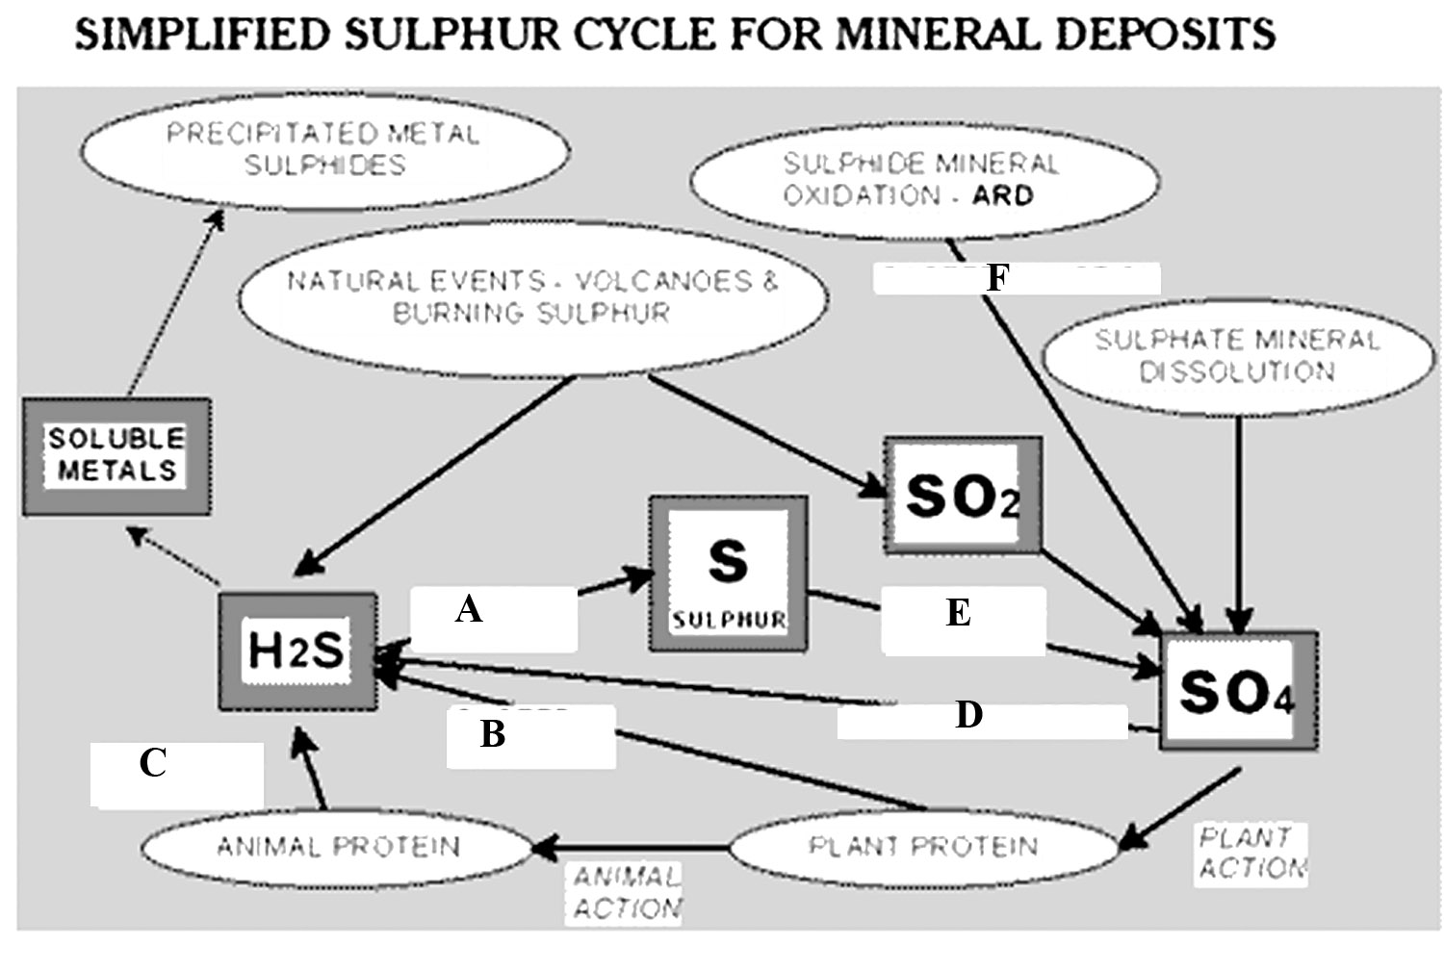

a. Name one microorganism involved in each of the following steps of the above diagram.

- ……………………………………………………………………………………………..
- ……………………………………………………………………………………………..
- ……………………………………………………………………………………………..
- ……………………………………………………………………………………………..
- ……………………………………………………………………………………………..
- ……………………………………………………………………………………………..

b. What are the features that are desirable in green manure crops?
……………………………………………………………………………………………………………………………………………………………………………………………………………………………………………………………………………………………………………………………………………………………………………………………………………………………………………………………………………………………………………………………………………………………………………………………………………………………………………………………………………………………………………………………………………………………………………………………………………………………………………………………………………………………………………………………………………………………………………………………..
c. Briefly explain how farm manure affects on the development of soil.
………………………………………………………………………………………………………………………………………………………………………………………………………………………………………………………………………………………………………………………………………………………………………………………………………………………………………………………………………………………………………………………………………………………………………………………………………………………………………………………………………………………………………………………………………………………………………………………………………………………………………………………………………………………………………………………………………………………………………………………………………………………………………………………………………………………………………………………………………………………………………………………………………………………………………………………………………………………………………………………………………………………………………………………………………………………………………………………………………………………………………………………………………………………………………………………………………………………………………………………………………………………………………………………………………………………………………………………………………………………………………………………………………………………………………………………………………………………………………………………………
…………………………………………………………………………………………………………
- Write two advantages and two disadvantages of mixed fertilizers.
……………………………………………………………………………………………………………………………………………………………………………………………………………………………………………………………………………………………………………………………………………………………………………………………………………………………………………………………………………………………………………………………………………………………………………………………………………………………………………………………………………………………………………………………………………………………………………………………………………………………………………………………………………………
……………………………………………………………………………………………………………………………………………………………………………………………………………………

3. a. What is soil erosion? ………………………………………………………………………………………………………………………………………………………………………………………………………………………………………………………………………………………………………………………………
b. List the factors that affect the rate of erosion.
…………………………………………………………………………………………………………………………………………………………………………………………………………………………………………………………………………………………………………………………………………………………………………………………………………………………………………………………………………………………………………………………………………………………………………………………………………………………………………………………………………………………………………………………………………………………………………
c. List six methods available to control water erosion and one principle behind each of the method you mentioned.
Method | Principle of the method

